salon management system

Distributive Database System

Mobeen Ahmed

17-Arid-0249

Database:

# Tables:

## Staff Table:

This table is used to manage Administrators for the purpose of logging and managing the records, A new admin can be added through SQL server but not through the software as the security may be sacrificed.

create table staff(id varchar(5),name varchar(30),passwrd varchar(36),contact varchar(20))

select * from staff

## Customer Table:

The Customer table is meant to be used for the purpose of assigning new customers, managing the customers, and take record of services used by them.

create table customer(id varchar(5),name varchar(30),phone varchar(20),srvce varchar(100),bill varchar(10))

select * from customer

## Receipt Table:

The receipt table is used to handle the customer services used for the sake of generation of bill and backup of all the records inserted ever.

create table receipt(cid varchar(5),sid varchar(5),price varchar(10),date datetime)

select * from receipt

# Procedures:

## **Create Customer:**

This procedure is used to register a new customer in our database.

create proc ins_cust(@id varchar(5),@name varchar(30),@phone varchar(20),@ser varchar(100),@bill varchar(10))

as

begin

insert into customer values(@id,@name,@phone,@ser,@bill)

end

**such as:**

execute ins_cust 1,'Ali','090010133','Gold Hair Cutting, Standard Facial, Gold Shave, Standard SPA','1100'

## **Delete Customer:**

This procedure delete record when customer refuses to pay the bill or avail the services he chooses, this call occurs on cancel button while bill is generated.

create proc del_cust

as

begin

delete from customer where id=(select MAX(id) from customer)

end

**A sample execution is given below:**

execute del_cust

# Triggers:

## **Insert trigger:**

Create TRIGGER INS_CUSTOMER ON CUSTOMER INSTEAD OF INSERT

AS

BEGIN

DECLARE @ID VARCHAR(30);

SET @ID = (SELECT ID FROM inserted)

IF(EXISTS (SELECT * FROM CUSTOMER WHERE ID=@ID))

PRINT 'ALREADY EXISTS'

ELSE

INSERT INTO CUSTOMER SELECT * FROM inserted

END

## **Delete trigger:**

Create trigger del on student after delete

as

begin

Select * from deleted

End

# Forms:

# Login form:

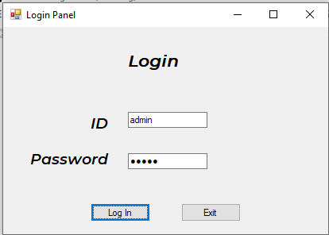 Login Form is the most initial form which is directed to the staff table through which only admin can access through and the process will go on.

# Menu form:

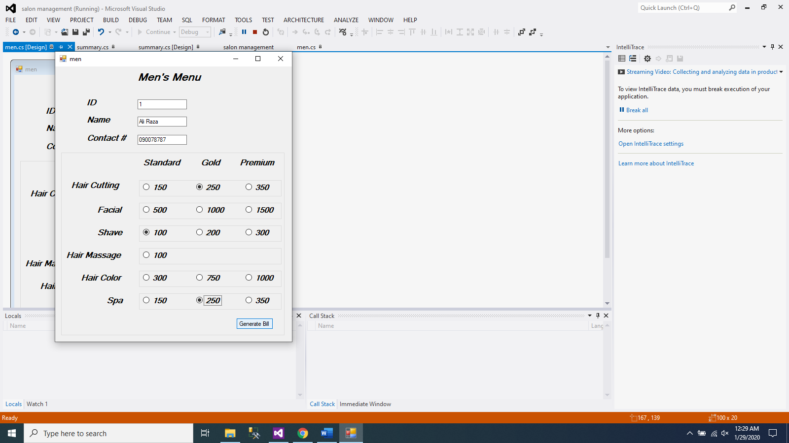 Menu Form comes after successful login by the staff member. In this form, services are being selected and basic information of customer is taken in order to generate our database.

# Booked Services form:

Booked Services/ Summary Form comes after the user has selected all the services and decided to pay the dues according to the services he selected.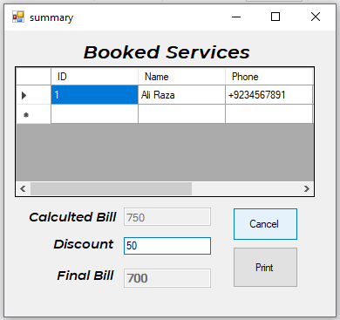

### **Cancel Button:**

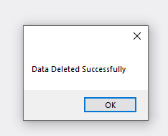 If customer wants to cancel the order, the record will be deleted and form will go back to main menu.

### **Print Button:**

If customer agree to pay the bill, the record will remain save, a bill will be printed and form will be committed and jumps to main menu

